***FACULTATEA DE AUTOMATICA***

***SI CALCULATOARE***

**DEPARTAMENTUL CALCULATOARE**

DSD PROJECT

**Students:**   
Radu Petringel & Emma Ioana Popovici

**Project supervisor:** Suta Adrian

***Contents:***

1.Specifications

2.Design

2.1 Black box

2.2 Detail diagram

3.Structure and functionality

3.1 Resources

3.2 FSM

4.Utility and results

5.Further development

6.Technical justifications for the design

**1. Specifications**

The project's objective was to create a device capable of simulating how a washing machine with manual mode and several automatic modes works. This project is implemented using Active-HDL via VHDL code, with top-level structural description and practical functionality demonstrated on FPGA board.

The machine is initially idle, with the washing machine door open and unlocked. The user can set the operating parameters manually (manual mode) or select one of the pre-programmed automatic modes.

**Operation Procedure:**

**Machine Activation:**

* Press **BTNR** (on/off button) to turn on the washing machine
* When activated, the machine automatically enters Manual mode
* Press **BTNR** again to switch to automatic mode
* Door must be closed (**SW0 ON**) before starting any program

**In manual mode, you can set:**

* **Temperature:** SW2 (30°C), SW3 (40°C), SW4 (60°C), SW5 (90°C)
* **Speed:** SW6 (800rpm), SW7 (1000rpm), SW8 (1200rpm)
* **Prewash:** SW9 (on/off)
* **Extra rinse:** SW10 (on/off)
* At least one temperature and one speed switch must be selected for the program to work

**The selectable automatic modes are as follows:**

* **Quick Wash** - 30°C, 1200rpm, no prewash, no extra rinse
* **Shirts** - 60°C, 800rpm, no prewash, no extra rinse
* **Dark Colors** - 40°C, 1000rpm, no prewash, extra rinse
* **Dirty Laundry** - 40°C, 1000rpm, with prewash, no extra rinse
* **Antiallergic** - 90°C, 1200rpm, no prewash, extra rinse

**Program Execution:** Each program contains the following steps:

1. **Prewash** (if selected): Feed water (10 seconds), heat water, rotate at 60rpm for 10 minutes, drain water (10 seconds)
2. **Main Wash:** Feed water (10 seconds), heat water, rotate at 60rpm for 20 minutes, drain water (10 seconds)
3. **Rinse:** Feed water (10 seconds), rotate at 120rpm for 10 minutes, drain water (10 seconds)
4. **Extra Rinse** (if selected): Repeat rinse cycle
5. **Spin:** Rotate at selected speed for 10 minutes

The running time of the program depends on the selected temperature (water comes with a temperature of 15°C and heats up 1°C in 2 seconds) and the selected functions.

**Safety Features:**

* The door locks after the program starts (**LED1 ON**) and opens after the program ends
* The program does not start with the door open
* Door unlocks 1 minute after program completion
* While the desired mode is selected, the program duration is displayed, and the remaining time is displayed after starting (the time is displayed on 7-segment displays)

**2. Design**

**2.1. Black box**

This first step involves identifying all inputs and outputs that may not be explicitly specified in the requirements but which the designer must add to implement the functionality on the board. The designer must identify the use cases of the project, take each case separately and go through it step by step, considering the restrictions of the Nexys4DDR board (16 switches, 5 buttons, 16 LEDs, 8 SSD).

O imagine care conține text, captură de ecran, Font, diagramă

Conținutul generat de inteligența artificială poate fi incorect.

**Hardware Mapping:**

* **BTNU:** Start program
* **BTNL:** Select mode (cycles through automatic modes)
* **BTNR:** On/off washing machine (and selects between manual and automatic)
* **BTNC:** Reset
* **SW0:** Door closed status
* **SW2-SW5:** Temperature selection (30°C, 40°C, 60°C, 90°C)
* **SW6-SW8:** Speed selection (800rpm, 1000rpm, 1200rpm)
* **SW9:** Prewash selection
* **SW10:** Extra rinse selection
* **LED0:** Door closed indicator
* **LED1:** Door locked indicator
* **LED2-LED10:** Parameter status indicators

**2.2. Detail diagram**

The system is broken down into Control Unit (CU) and Execution Unit (EU). The Control Unit contains the decision-making logic, while the Execution Unit contains the system resources and timing components.

O imagine care conține text, captură de ecran, diagramă

Conținutul generat de inteligența artificială poate fi incorect.

**Input Classification:**

* **Data inputs:** Parameter values from switches (temperature, speed, prewash, extra rinse settings)
* **Control inputs:** Button presses for confirmation, mode selection, machine on/off, program start

**Output Classification:**

* **Data outputs:** Values displayed to the user (program time, remaining time, current parameters)
* **Control outputs:** Status indication signals (LEDs for door status, parameter indication, program phase)

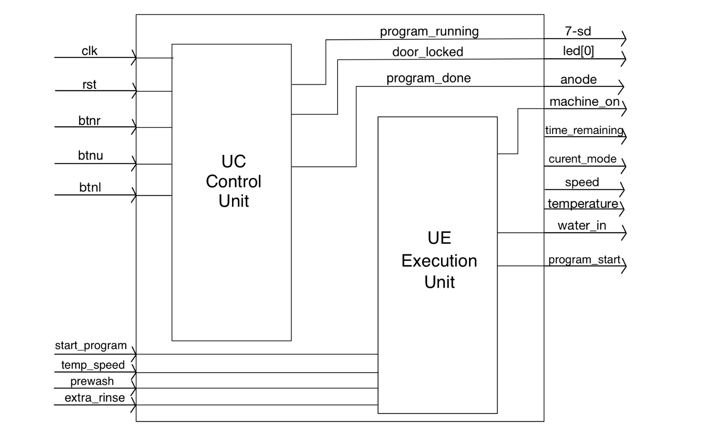

**3. Structure and functionality**

**3.1 RESOURCES:**

1. **Clock Divider (1 second pulse generator)** • Generates pulse_1s signal for timing control  
   • Input: 100MHz system clock  
   • Output: 1-second pulse for FSM timing

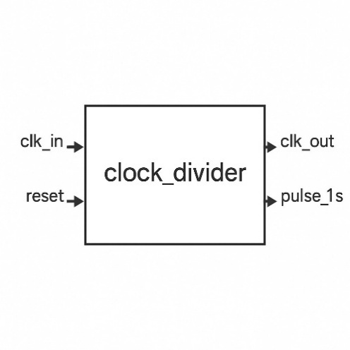

1. **MPG Units (Button Debouncing)** • Three MPG units for BTNU, BTNL, BTNR  
   • Input: Raw button signals  
   • Output: Clean, debounced button signals

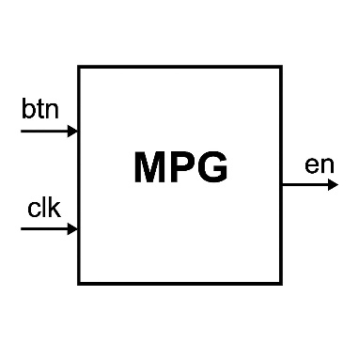

**3. Mode Selector** • Cycles through washing modes based on button presses  
• Inputs: Machine on, select button  
• Output: Current mode (3-bit signal)

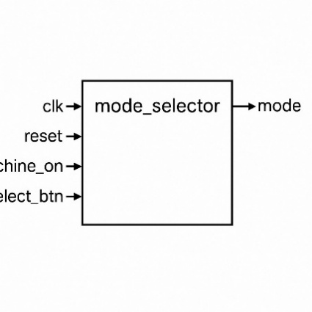

1. **Parameter Controller** • Manages parameter selection based on mode and switches  
   • Inputs: Mode, switch states  
   • Outputs: Temperature, speed, prewash, extra rinse, parameter validity

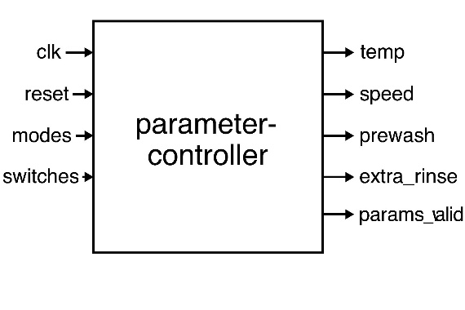

1. **Time Calculator** • Calculates total program time based on parameters  
   • Inputs: Temperature, speed, prewash, extra rinse  
   • Output: Total program time (16-bit)

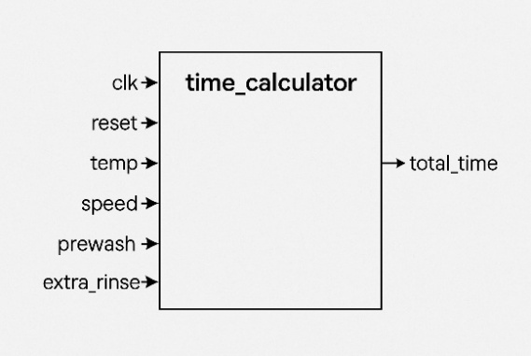

1. **Wash Program FSM (Main Controller)** • Central state machine controlling wash cycle  
   • Multiple states: IDLE, FILL, HEAT, WASH, DRAIN, RINSE, SPIN  
   • Controls all physical processes and timing

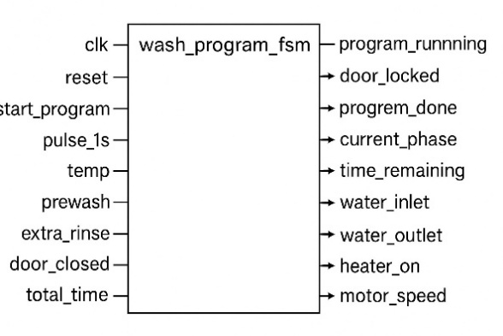

1. **Seven Segment Controller** • Displays time information on 7-segment display  
   • Input: Time value (16-bit)  
   • Outputs: Segment data and anode control

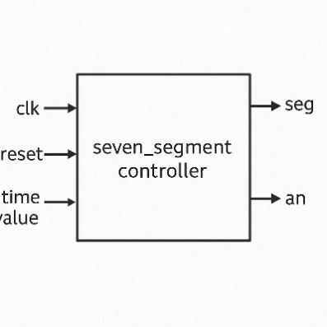

**3.2. FSM**

The main control logic is implemented as a comprehensive finite state machine with the following key states:

**Primary States:**

* **IDLE:** Machine waiting for program start
* **Mode Selection States:** Manual (000), Quick Wash (001), Shirts (010), Dark Colors (011), Dirty Laundry (100), Antiallergic (101)

**Washing Process States:**

* **PREWASH_FILL, PREWASH_HEAT, PREWASH_WASH, PREWASH_DRAIN:** Prewash cycle (if selected)
* **MAIN_FILL, MAIN_HEAT, MAIN_WASH, MAIN_DRAIN:** Main washing cycle
* **RINSE_FILL, RINSE_WASH, RINSE_DRAIN:** Primary rinse cycle
* **EXTRA_RINSE_FILL, EXTRA_RINSE_WASH, EXTRA_RINSE_DRAIN:** Additional rinse (if selected)
* **SPIN:** Final spin cycle at selected speed
* **DOOR_UNLOCK_DELAY:** 60-second delay before door unlock
* **COMPLETE:** Program finished, return to idle

The FSM transitions are controlled by timing pulses and completion signals from various subsystems, ensuring proper sequencing of all wash operations.

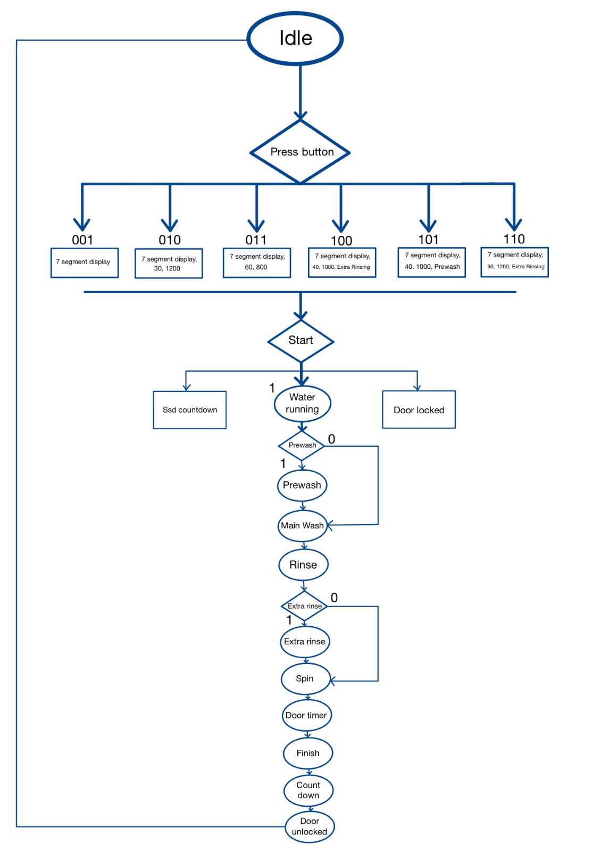

The detailed implementation diagram shows the complete system with all interconnections between Control Unit and Execution Unit components. It includes:

• All input/output mappings to FPGA pins  
• Internal signal routing between components  
• Clock distribution and timing signals  
• Control signal flow from FSM to physical processes  
• Status feedback paths  
• Display and LED control logic

The diagram demonstrates how the modular design allows for clean separation of concerns while maintaining proper system integration**.**

O imagine care conține schiță, diagramă, Plan, Desen tehnic

Conținutul generat de inteligența artificială poate fi incorect.

**4. Utility and results**

The project demonstrates a fully functional washing machine controller with the following operational sequence:

**Step-by-Step Operation:**

1. **Initial Setup:** Ensure door is closed (turn SW0 ON), LED0 will turn on indicating door is closed, then press BTNR to turn on the washing machine.

O imagine care conține electronice, Inginerie electronică, Componentă de computer, Componentă electronică

Conținutul generat de inteligența artificială poate fi incorect.

1. **Mode Selection:** Press BTNL repeatedly to cycle through modes: Manual → Quick wash → Shirts → Dark colors → Dirty laundry → Antiallergic → Manual. LEDs show active parameters for each mode.

2.1) Quick wash

O imagine care conține electronice, Inginerie electronică, Componentă electronică, Componenta circuitului

Conținutul generat de inteligența artificială poate fi incorect.

2.2)Shirts

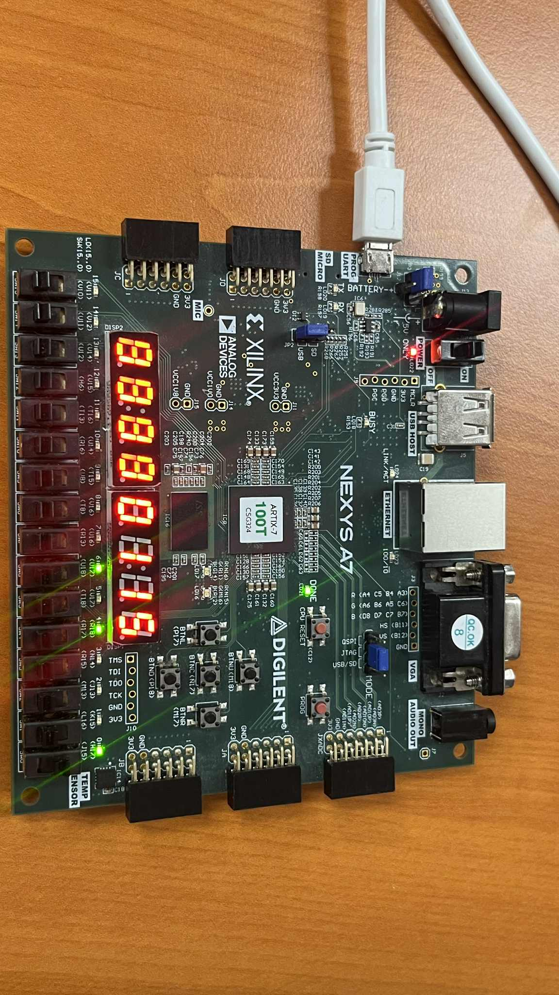

2.3)Dark colors

O imagine care conține electronice, Inginerie electronică, Componentă electronică, Componenta circuitului

Conținutul generat de inteligența artificială poate fi incorect.

2.4)Dirty laundry

O imagine care conține electronice, Inginerie electronică, Componentă electronică, Componenta circuitului

Conținutul generat de inteligența artificială poate fi incorect.

2.5)Antiallergic

O imagine care conține electronice, Inginerie electronică, Componentă electronică, Componenta circuitului

Conținutul generat de inteligența artificială poate fi incorect.

2.6)Manual

O imagine care conține electronice, Inginerie electronică, Componentă electronică, Componenta circuitului

Conținutul generat de inteligența artificială poate fi incorect.

1. **Manual Mode Parameter Setting:**
   * Select temperature by turning ON one of SW2 (30°C), SW3 (40°C), SW4 (60°C), SW5 (90°C)

O imagine care conține electronice, Inginerie electronică, Componentă electronică, Componenta circuitului

Conținutul generat de inteligența artificială poate fi incorect.

* + Select speed by turning ON one of SW6 (800rpm), SW7 (1000rpm), SW8 (1200rpm)

O imagine care conține electronice, Inginerie electronică, Componentă electronică, Componenta circuitului

Conținutul generat de inteligența artificială poate fi incorect.

* + Optionally turn ON SW9 (prewash) and/or SW10 (extra rinse)

O imagine care conține electronice, Inginerie electronică, Componentă electronică, Componenta circuitului

Conținutul generat de inteligența artificială poate fi incorect.

* + The 7-segment display shows calculated program time when both temperature and speed are selected

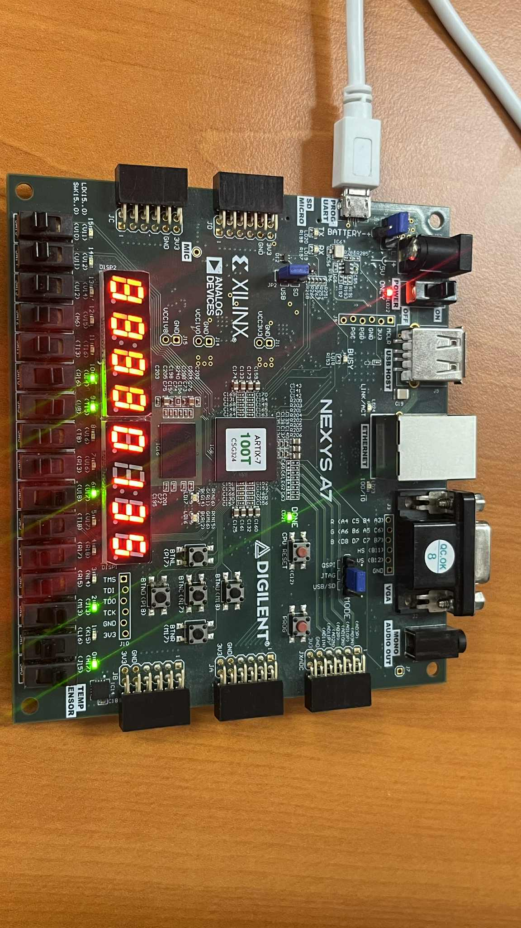

1. **Starting the Program:** Press BTNU (start program) when parameters are valid. LED1 turns on (door locked), 7-segment display begins countdown, and the program executes automatically through all phases.

O imagine care conține electronice, Inginerie electronică, Componenta circuitului, Componentă electronică

Conținutul generat de inteligența artificială poate fi incorect.

O imagine care conține electronice, circuit, Inginerie electronică, Componentă electronică

Conținutul generat de inteligența artificială poate fi incorect.

1. **Program Completion:** When countdown reaches 0, door unlock timer starts (60 seconds). After unlock delay, LED1 turns off. Turn SW0 OFF (open door) to complete the cycle.

**Display Behavior:**

* 7-segment display shows program time in MM:SS format
* LEDs 2-10 indicate active parameters
* LED0 shows door status, LED1 shows lock status
* During program execution, the display shows remaining time counting down

The system successfully demonstrates all required functionality including mode selection, parameter configuration, time calculation, and complete wash cycle execution with proper safety interlocks.

**5. Further development**

Future enhancements to improve the washing machine controller:

**Proposed Improvements:**

1. **Load Detection System:** Add ADC interface for current measurement to detect laundry load and automatically adjust cycle times and water levels accordingly.
2. **Advanced User Interface:** Replace basic LED indicators with an LCD display showing detailed status information, current phase, remaining time, and error messages.
3. **Energy Efficiency Modes:** Implement eco-mode with optimized energy consumption through variable speed control and intelligent heating strategies.
4. **Enhanced Safety Features:** Add water level sensors, temperature monitoring, and emergency stop functionality with detailed error reporting.
5. **Program Customization:** Allow users to create and save custom wash programs with personalized parameter combinations.

**6. Technical justifications for the design**

**What we implemented in our project:**

1. **Finite State Machine Implementation:** A comprehensive FSM provides precise control over the wash sequence, allows for complex timing relationships, and makes it easy to add new wash phases or modify existing ones. This approach ensures reliable operation and clear program flow.
2. **Modular Component Design:** Separating functionality into distinct components (mode selector, parameter controller, time calculator, etc.) improves code maintainability, enables easier debugging, and allows for independent testing of each subsystem.
3. **Clock Division Strategy:** Using a single clock divider generating 1-second pulses simplifies timing across the system and ensures all modules are synchronized. This reduces the need for multiple timing sources, saving FPGA resources and improving reliability.
4. **LED Control Implementation:** Mode-based LED mapping provides intuitive feedback to users, making the system easier to understand and operate. Each parameter and status has a dedicated indicator for clear system state visibility.
5. **Safety-First Approach:** Implementing door interlocks, parameter validation, and proper state sequencing ensures safe operation and prevents damage to the system or injury to users.

The design includes all the required features, such as two modes: manual and automatic. All programs consist of the three main steps: main wash, rinse, and centrifugation. Additionally, none of the programs start unless the door is locked. All information about time calculation and countdown is displayed on the 7-segment display.